Create Client Table
mysql> CREATE TABLE Clients ( client_id INT NOT NULL AUTO_INCREMENT, client_name VARCHAR(150) NOT NULL, client_email VARCHAR(25), client_address VARCHAR(255), client_password VARCHAR(20), PRIMARY KEY (client_id) );
Query OK, 0 rows affected (0.06 sec)

Insert records to the table
mysql> INSERT INTO Clients VALUES(2, "Sheldon Quigley", "hbingley1@plala.or.jp", "560 Penstock Drive, Grass Valley, CA","OWsTbMUgFc");
Query OK, 1 row affected (0.02 sec)
mysql> INSERT INTO Clients VALUES(3, "Terrill Hills", "rshawe2@51.la", "560 Penstock Drive, Grass Valley, CA", "OWsTbMUgFc");
Query OK, 1 row affected (0.01 sec)

Show Tables:
mysql> SELECT * FROM Clients;
+-----------+-----------------+-----------------------+-----------------------------------------+-----------------+
| client_id | client_name | client_email | client_address | client_password |
+-----------+-----------------+-----------------------+-----------------------------------------+-----------------+
| 1 | Terry Medhurst | atuny0@sohu.com | 1745 T Street Southeast, Washington, DC | 9uQFF1Lh |
| 2 | Sheldon Quigley | hbingley1@plala.or.jp | 560 Penstock Drive, Grass Valley, CA | OWsTbMUgFc |
| 3 | Terrill Hills | rshawe2@51.la | 560 Penstock Drive, Grass Valley, CA | OWsTbMUgFc |
+-----------+-----------------+-----------------------+-----------------------------------------+-----------------+
3 rows in set (0.00 sec)

Create Meetings Table
mysql> CREATE TABLE Meetings ( meeting_id INT NOT NULL AUTO_INCREMENT, client_name VARCHAR(150) NOT NULL, meeting_topic VARCHAR(255), meeting_start_time VARCHAR(20), meeting_people_count TINYINT, client_id INT, PRIMARY KEY (meeting_id), FOREIGN KEY (client_id) REFERENCES Clients(client_id) );
Insert records to Meetings Table
mysql> INSERT INTO Meetings VALUES(1, "Terry Medhurst ","Discuss Project1 Requirements","2024-03-25T08:00", 5, 1);
Query OK, 1 row affected (0.02 sec)
mysql> INSERT INTO Meetings VALUES(2, "Terry Medhurst","Discuss Project1 Feature List","2024-04-25T10:00",10,1);
Query OK, 1 row affected (0.02 sec)
mysql> INSERT INTO Meetings VALUES(3, "Sheldon Quigley","Discuss Project2 Requirements","2024-03-30T10:00",7,2);
Query OK, 1 row affected (0.01 sec)
mysql> INSERT INTO Meetings VALUES(4, "Sheldon Quigley","Discuss Project2 FeatureList","2024-04-15T10:00",4,2);
Query OK, 1 row affected (0.02 sec)
mysql> INSERT INTO Meetings VALUES(5, "Terrill Hills","Discuss Project Expectations and Timeline","2024-04-19T10:00",5,3);
Query OK, 1 row affected (0.03 sec)

Show Table:
mysql> SELECT * FROM Meetings;
+------------+-----------------+-------------------------------------------+--------------------+----------------------+-----------+
| meeting_id | client_name | meeting_topic | meeting_start_time | meeting_people_count | client_id |
+------------+-----------------+-------------------------------------------+--------------------+----------------------+-----------+
| 1 | Terry Medhurst | Discuss Project1 Requirements | 2024-03-25T08:00 | 5 | 1 |
| 2 | Terry Medhurst | Discuss Project1 Feature List | 2024-04-25T10:00 | 10 | 1 |
| 3 | Sheldon Quigley | Discuss Project2 Requirements | 2024-03-30T10:00 | 7 | 2 |
| 4 | Sheldon Quigley | Discuss Project2 FeatureList | 2024-04-15T10:00 | 4 | 2 |
| 5 | Terrill Hills | Discuss Project Expectations and Timeline | 2024-04-19T10:00 | 5 | 3 |
+------------+-----------------+-------------------------------------------+--------------------+----------------------+-----------+
5 rows in set (0.00 sec)

- Create a database named manage_meetings.
- Add 2 tables - Clients and Meetings
- Make client-id as PRIMARY KEY for Clients table.
- Make meeting_id as PRIMARY KEY of Meetings and Clients(client_id) as FOREIGN KEY.

Meetings Table Records
mysql> SELECT * FROM Meetings;
+------------+-----------------+-------------------------------------------+--------------------+----------------------+-----------+
| meeting_id | client_name | meeting_topic | meeting_start_time | meeting_people_count | client_id |
+------------+-----------------+-------------------------------------------+--------------------+----------------------+-----------+
| 1 | Terry Medhurst | Discuss Project1 Requirements | 2024-03-25T08:00 | 5 | 1 |
| 2 | Terry Medhurst | Discuss Project1 Feature List | 2024-04-25T10:00 | 10 | 1 |
| 3 | Sheldon Quigley | Discuss Project2 Requirements | 2024-03-30T10:00 | 7 | 2 |
| 4 | Sheldon Quigley | Discuss Project2 FeatureList | 2024-04-15T10:00 | 4 | 2 |
| 5 | Terrill Hills | Discuss Project Expectations and Timeline | 2024-04-19T10:00 | 5 | 3 |
+------------+-----------------+-------------------------------------------+--------------------+----------------------+-----------+
5 rows in set (0.00 sec)

Clients Table Records
mysql> SELECT * FROM Clients;
+-----------+-----------------+-----------------------+-----------------------------------------+-----------------+
| client_id | client_name | client_email | client_address | client_password |
+-----------+-----------------+-----------------------+-----------------------------------------+-----------------+
| 1 | Terry Medhurst | atuny0@sohu.com | 1745 T Street Southeast, Washington, DC | 9uQFF1Lh |
| 2 | Sheldon Quigley | hbingley1@plala.or.jp | 560 Penstock Drive, Grass Valley, CA | OWsTbMUgFc |
| 3 | Terrill Hills | rshawe2@51.la | 560 Penstock Drive, Grass Valley, CA | OWsTbMUgFc |
+-----------+-----------------+-----------------------+-----------------------------------------+-----------------+
3 rows in set (0.00 sec)
Find all meetings for Client with client_id=1
mysql> SELECT
-> meeting_id,
-> meeting_topic,
-> meeting_start_time
-> FROM
-> Meetings
-> WHERE
-> client_id = 1;
+------------+-------------------------------+--------------------+
| meeting_id | meeting_topic | meeting_start_time |
+------------+-------------------------------+--------------------+
| 1 | Discuss Project1 Requirements | 2024-03-25T08:00 |
| 2 | Discuss Project1 Feature List | 2024-04-25T10:00 |
+------------+-------------------------------+--------------------+
2 rows in set (0.00 sec)

mysql> SELECT c.client_name, m.meeting_topic, m.meeting_start_time FROM Meetings AS m INNER JOIN Clients AS c ON m.client_id = c.client_id WHERE m.client_id =1;
+----------------+-------------------------------+--------------------+
| client_name | meeting_topic | meeting_start_time |
+----------------+-------------------------------+--------------------+
| Terry Medhurst | Discuss Project1 Requirements | 2024-03-25T08:00 |
| Terry Medhurst | Discuss Project1 Feature List | 2024-04-25T10:00 |
+----------------+-------------------------------+--------------------+
2 rows in set (0.00 sec)mysql> SELECT c.client_name, m.meeting_topic, m.meeting_start_time FROM Meetings AS m INNER JOIN Clients AS c ON m.client_id = c.client_id WHERE m.client_id =2;
+-----------------+-------------------------------+--------------------+
| client_name | meeting_topic | meeting_start_time |
+-----------------+-------------------------------+--------------------+
| Sheldon Quigley | Discuss Project2 Requirements | 2024-03-30T10:00 |
| Sheldon Quigley | DiscCreate a database named manage_meetings.

Add 2 tables - Clients and Meetings

Make client-id as PRIMARY KEY for Clients table.

Make meeting_id as PRIMARY KEY of Meetings and Clients(client_id) as FOREIGN KEY.

Meetings Table Records

mysql> SELECT * FROM Meetings;
+------------+-----------------+-------------------------------------------+--------------------+----------------------+-----------+
| meeting_id | client_name | meeting_topic | meeting_start_time | meeting_people_count | client_id |
+------------+-----------------+-------------------------------------------+--------------------+----------------------+-----------+
| 1 | Terry Medhurst | Discuss Project1 Requirements | 2024-03-25T08:00 | 5 | 1 |
| 2 | Terry Medhurst | Discuss Project1 Feature List | 2024-04-25T10:00 | 10 | 1 |
| 3 | Sheldon Quigley | Discuss Project2 Requirements | 2024-03-30T10:00 | 7 | 2 |
| 4 | Sheldon Quigley | Discuss Project2 FeatureList | 2024-04-15T10:00 | 4 | 2 |
| 5 | Terrill Hills | Discuss Project Expectations and Timeline | 2024-04-19T10:00 | 5 | 3 |
+------------+-----------------+-------------------------------------------+--------------------+----------------------+-----------+
5 rows in set (0.00 sec)

Clients Table Records

mysql> SELECT * FROM Clients;
+-----------+-----------------+-----------------------+-----------------------------------------+-----------------+
| client_id | client_name | client_email | client_address | client_password |
+-----------+-----------------+-----------------------+-----------------------------------------+-----------------+
| 1 | Terry Medhurst | atuny0@sohu.com | 1745 T Street Southeast, Washington, DC | 9uQFF1Lh |
| 2 | Sheldon Quigley | hbingley1@plala.or.jp | 560 Penstock Drive, Grass Valley, CA | OWsTbMUgFc |
| 3 | Terrill Hills | rshawe2@51.la | 560 Penstock Drive, Grass Valley, CA | OWsTbMUgFc |
+-----------+-----------------+-----------------------+-----------------------------------------+-----------------+
3 rows in set (0.00 sec)

Find all meetings for Client with client_id=1

mysql> SELECT
-> meeting_id,
-> meeting_topic,
-> meeting_start_time
-> FROM
-> Meetings
-> WHERE
-> client_id = 1;
+------------+-------------------------------+--------------------+
| meeting_id | meeting_topic | meeting_start_time |
+------------+-------------------------------+--------------------+
| 1 | Discuss Project1 Requirements | 2024-03-25T08:00 |
| 2 | Discuss Project1 Feature List | 2024-04-25T10:00 |
+------------+-------------------------------+--------------------+
2 rows in set (0.00 sec)

mysql> SELECT c.client_name, m.meeting_topic, m.meeting_start_time FROM Meetings AS m INNER JOIN Clients AS c ON m.client_id = c.client_id WHERE m.client_id =1;
+----------------+-------------------------------+--------------------+
| client_name | meeting_topic | meeting_start_time |
+----------------+-------------------------------+--------------------+
| Terry Medhurst | Discuss Project1 Requirements | 2024-03-25T08:00 |
| Terry Medhurst | Discuss Project1 Feature List | 2024-04-25T10:00 |
+----------------+-------------------------------+--------------------+
2 rows in set (0.00 sec)mysql> SELECT c.client_name, m.meeting_topic, m.meeting_start_time FROM Meetings AS m INNER JOIN Clients AS c ON m.client_id = c.client_id WHERE m.client_id =2;
+-----------------+-------------------------------+--------------------+
| client_name | meeting_topic | meeting_start_time |
+-----------------+-------------------------------+--------------------+
| Sheldon Quigley | Discuss Project2 Requirements | 2024-03-30T10:00 |
| Sheldon Quigley | Discuss Project2 FeatureList | 2024-04-15T10:00 |
+-----------------+-------------------------------+--------------------+
2 rows in set (0.00 sec)

Find all meetings for Client with client_id=2

mysql> SELECT meeting_id, meeting_topic, meeting_start_time FROM Meetings WHERE client_id = 2;
+------------+-------------------------------+--------------------+
| meeting_id | meeting_topic | meeting_start_time |
+------------+-------------------------------+--------------------+
| 3 | Discuss Project2 Requirements | 2024-03-30T10:00 |
| 4 | Discuss Project2 FeatureList | 2024-04-15T10:00 |
+------------+-------------------------------+--------------------+
2 rows in set (0.00 sec)

Find all meetings for Client with client_id=3

mysql> SELECT meeting_id, meeting_topic, meeting_start_time FROM Meetings WHERE client_id = 3;
+------------+-------------------------------------------+--------------------+
| meeting_id | meeting_topic | meeting_start_time |
+------------+-------------------------------------------+--------------------+
| 5 | Discuss Project Expectations and Timeline | 2024-04-19T10:00 |
+------------+-------------------------------------------+--------------------+
1 row in set (0.00 sec)

mysql> SELECT c.client_name, m.meeting_topic, m.meeting_start_time FROM Meetings AS m INNER JOIN Clients AS c ON m.client_id = c.client_id WHERE m.client_id =2;
+-----------------+-------------------------------+--------------------+
| client_name | meeting_topic | meeting_start_time |
+-----------------+-------------------------------+--------------------+
| Sheldon Quigley | Discuss Project2 Requirements | 2024-03-30T10:00 |
| Sheldon Quigley | Discuss Project2 FeatureList | 2024-04-15T10:00 |
+-----------------+-------------------------------+--------------------+
2 rows in set (0.00 sec)uss Project2 FeatureList | 2024-04-15T10:00 |
+-----------------+-------------------------------+--------------------+
2 rows in set (0.00 sec)
Find all meetings for Client with client_id=2
mysql> SELECT meeting_id, meeting_topic, meeting_start_time FROM Meetings WHERE client_id = 2;
+------------+-------------------------------+--------------------+
| meeting_id | meeting_topic | meeting_start_time |
+------------+-------------------------------+--------------------+
| 3 | Discuss Project2 Requirements | 2024-03-30T10:00 |
| 4 | Discuss Project2 FeatureList | 2024-04-15T10:00 |
+------------+-------------------------------+--------------------+
2 rows in set (0.00 sec)

Find all meetings for Client with client_id=3
mysql> SELECT meeting_id, meeting_topic, meeting_start_time FROM Meetings WHERE client_id = 3;
+------------+-------------------------------------------+--------------------+
| meeting_id | meeting_topic | meeting_start_time |
+------------+-------------------------------------------+--------------------+
| 5 | Discuss Project Expectations and Timeline | 2024-04-19T10:00 |
+------------+-------------------------------------------+--------------------+
1 row in set (0.00 sec)

mysql> SELECT c.client_name, m.meeting_topic, m.meeting_start_time FROM Meetings AS m INNER JOIN Clients AS c ON m.client_id = c.client_id WHERE m.client_id =2;
+-----------------+-------------------------------+--------------------+
| client_name | meeting_topic | meeting_start_time |
+-----------------+-------------------------------+--------------------+
| Sheldon Quigley | Discuss Project2 Requirements | 2024-03-30T10:00 |
| Sheldon Quigley | Discuss Project2 FeatureList | 2024-04-15T10:00 |
+-----------------+-------------------------------+--------------------+
2 rows in set (0.00 sec)

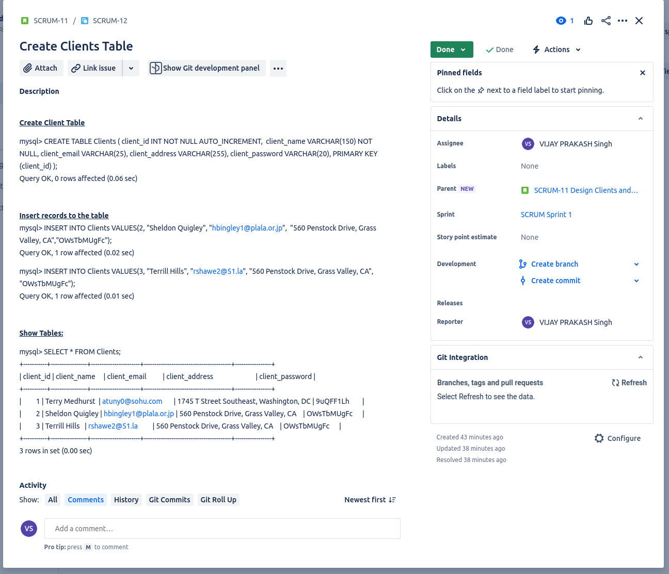

Create a database named manage_meetings.

Add 2 tables - Clients and Meetings

Make client-id as PRIMARY KEY for Clients table.

Make meeting_id as PRIMARY KEY of Meetings and Clients(client_id) as FOREIGN KEY.

Meetings Table Records

mysql> SELECT * FROM Meetings;
+------------+-----------------+-------------------------------------------+--------------------+----------------------+-----------+
| meeting_id | client_name | meeting_topic | meeting_start_time | meeting_people_count | client_id |
+------------+-----------------+-------------------------------------------+--------------------+----------------------+-----------+
| 1 | Terry Medhurst | Discuss Project1 Requirements | 2024-03-25T08:00 | 5 | 1 |
| 2 | Terry Medhurst | Discuss Project1 Feature List | 2024-04-25T10:00 | 10 | 1 |
| 3 | Sheldon Quigley | Discuss Project2 Requirements | 2024-03-30T10:00 | 7 | 2 |
| 4 | Sheldon Quigley | Discuss Project2 FeatureList | 2024-04-15T10:00 | 4 | 2 |
| 5 | Terrill Hills | Discuss Project Expectations and Timeline | 2024-04-19T10:00 | 5 | 3 |
+------------+-----------------+-------------------------------------------+--------------------+----------------------+-----------+
5 rows in set (0.00 sec)

Clients Table Records

mysql> SELECT * FROM Clients;
+-----------+-----------------+-----------------------+-----------------------------------------+-----------------+
| client_id | client_name | client_email | client_address | client_password |
+-----------+-----------------+-----------------------+-----------------------------------------+-----------------+
| 1 | Terry Medhurst | atuny0@sohu.com | 1745 T Street Southeast, Washington, DC | 9uQFF1Lh |
| 2 | Sheldon Quigley | hbingley1@plala.or.jp | 560 Penstock Drive, Grass Valley, CA | OWsTbMUgFc |
| 3 | Terrill Hills | rshawe2@51.la | 560 Penstock Drive, Grass Valley, CA | OWsTbMUgFc |
+-----------+-----------------+-----------------------+-----------------------------------------+-----------------+
3 rows in set (0.00 sec)

Find all meetings for Client with client_id=1

mysql> SELECT
-> meeting_id,
-> meeting_topic,
-> meeting_start_time
-> FROM
-> Meetings
-> WHERE
-> client_id = 1;
+------------+-------------------------------+--------------------+
| meeting_id | meeting_topic | meeting_start_time |
+------------+-------------------------------+--------------------+
| 1 | Discuss Project1 Requirements | 2024-03-25T08:00 |
| 2 | Discuss Project1 Feature List | 2024-04-25T10:00 |
+------------+-------------------------------+--------------------+
2 rows in set (0.00 sec)

mysql> SELECT c.client_name, m.meeting_topic, m.meeting_start_time FROM Meetings AS m INNER JOIN Clients AS c ON m.client_id = c.client_id WHERE m.client_id =1;
+----------------+-------------------------------+--------------------+
| client_name | meeting_topic | meeting_start_time |
+----------------+-------------------------------+--------------------+
| Terry Medhurst | Discuss Project1 Requirements | 2024-03-25T08:00 |
| Terry Medhurst | Discuss Project1 Feature List | 2024-04-25T10:00 |
+----------------+-------------------------------+--------------------+
2 rows in set (0.00 sec)mysql> SELECT c.client_name, m.meeting_topic, m.meeting_start_time FROM Meetings AS m INNER JOIN Clients AS c ON m.client_id = c.client_id WHERE m.client_id =2;
+-----------------+-------------------------------+--------------------+
| client_name | meeting_topic | meeting_start_time |
+-----------------+-------------------------------+--------------------+
| Sheldon Quigley | Discuss Project2 Requirements | 2024-03-30T10:00 |
| Sheldon Quigley | Discuss Project2 FeatureList | 2024-04-15T10:00 |
+-----------------+-------------------------------+--------------------+
2 rows in set (0.00 sec)

Find all meetings for Client with client_id=2

mysql> SELECT meeting_id, meeting_topic, meeting_start_time FROM Meetings WHERE client_id = 2;
+------------+-------------------------------+--------------------+
| meeting_id | meeting_topic | meeting_start_time |
+------------+-------------------------------+--------------------+
| 3 | Discuss Project2 Requirements | 2024-03-30T10:00 |
| 4 | Discuss Project2 FeatureList | 2024-04-15T10:00 |
+------------+-------------------------------+--------------------+
2 rows in set (0.00 sec)

Find all meetings for Client with client_id=3

mysql> SELECT meeting_id, meeting_topic, meeting_start_time FROM Meetings WHERE client_id = 3;
+------------+-------------------------------------------+--------------------+
| meeting_id | meeting_topic | meeting_start_time |
+------------+-------------------------------------------+--------------------+
| 5 | Discuss Project Expectations and Timeline | 2024-04-19T10:00 |
+------------+-------------------------------------------+--------------------+
1 row in set (0.00 sec)

mysql> SELECT c.client_name, m.meeting_topic, m.meeting_start_time FROM Meetings AS m INNER JOIN Clients AS c ON m.client_id = c.client_id WHERE m.client_id =2;
+-----------------+-------------------------------+--------------------+
| client_name | meeting_topic | meeting_start_time |
+-----------------+-------------------------------+--------------------+
| Sheldon Quigley | Discuss Project2 Requirements | 2024-03-30T10:00 |
| Sheldon Quigley | Discuss Project2 FeatureList | 2024-04-15T10:00 |
+-----------------+-------------------------------+--------------------+
2 rows in set (0.00 sec)

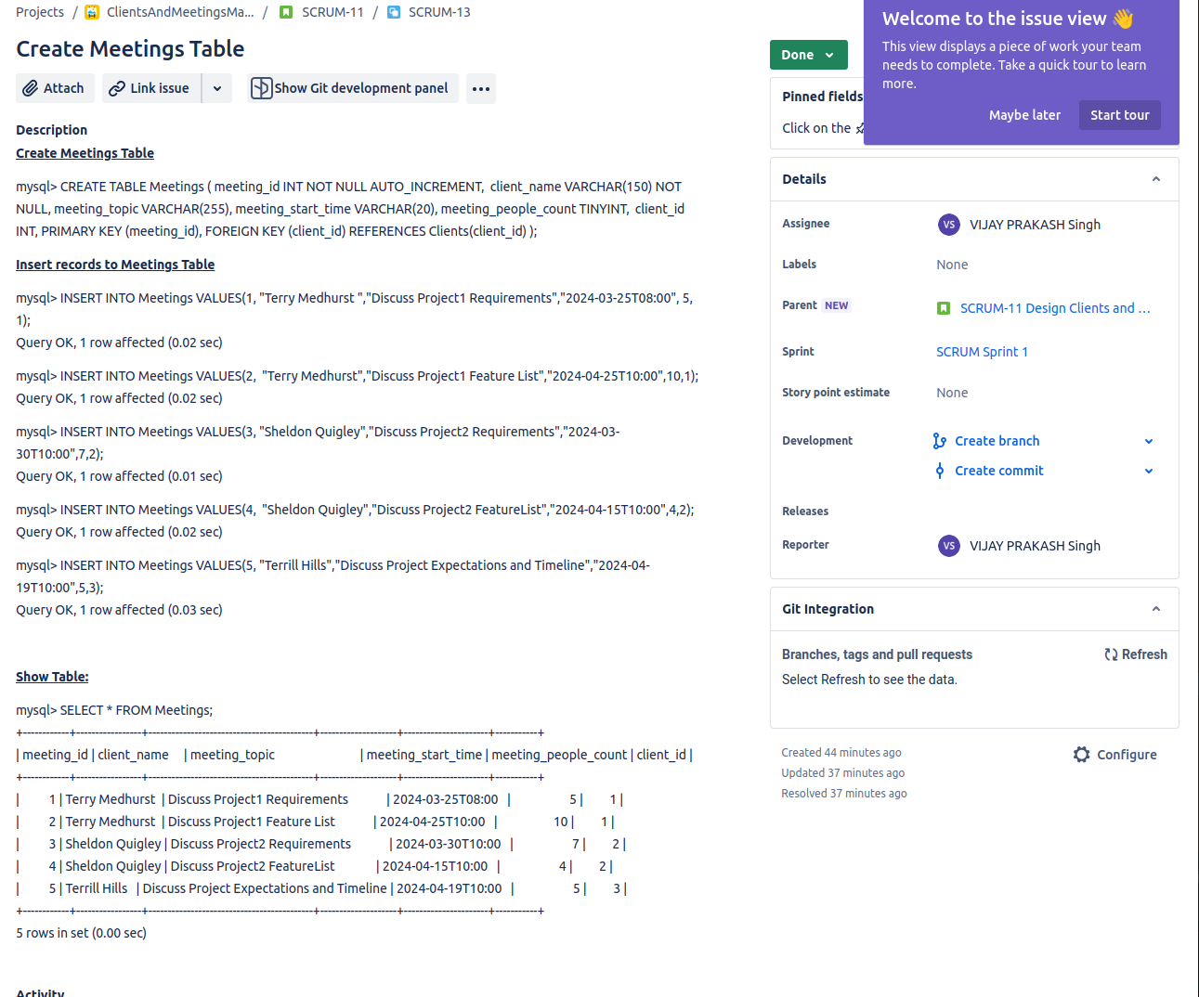
Jhfgfgkdfhksdhvg

